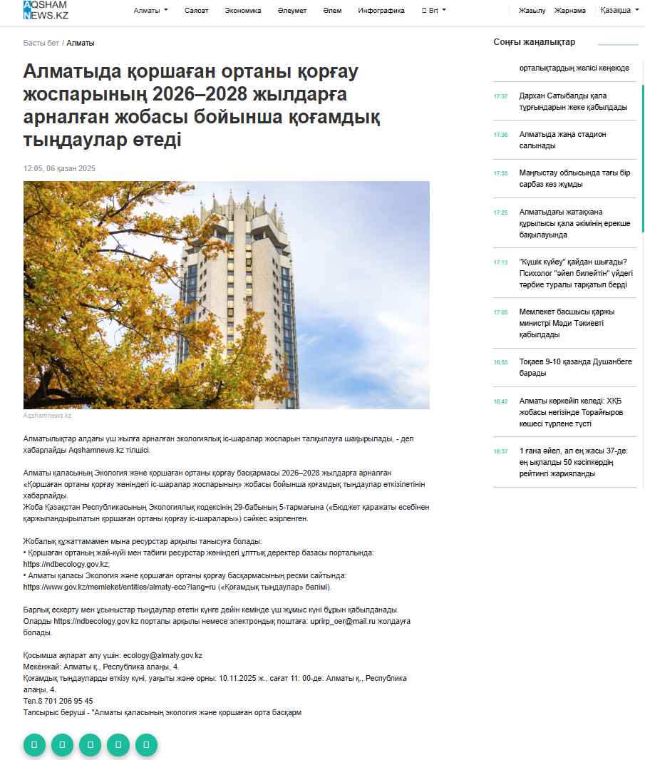
https://aqshamnews.kz/kz/article/almatyda-qorshagan-ortany-qorgau-josparynyn-20262028-jyldarga-arnalgan-jobasy-boiynsha-qogamdyq-tyndaular-otedi.html

